create table deposit(account_no varchar2(10),cust_nm varchar2(20),branch_nm varchar2(20),amount number(20,3),amt_dt date);

insert into deposit values('100','sanjana','sbi','2000','1-jan-1995');

insert into deposit values('101','sagar','sbi','1000','10-feb-1995');

insert into deposit values('102','sameer','bob','4000','16-sep-1996');

insert into deposit values('103','sanam','sbi','5000','15-mar-1996');

insert into deposit values('104','sagarika','bob','7000','12-mar-1996');

insert into deposit values('105','sonam','sbi','6000','12-sep-1995');

insert into deposit values('106','priya','sbi','2000','12-feb-1996');

insert into deposit values('107','shreya','bob','4000','18-jan-1995');

insert into deposit values('108','shaheeda','sbi','1500','20-apr-1995');

insert into deposit values('109','rasika','bob','2000','21-apr-1996');

select * from deposit;

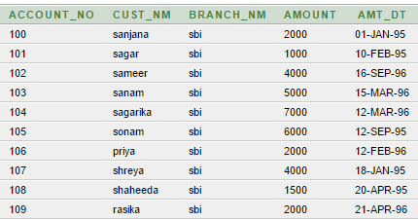

create table branch(branch_nm varchar2(20),city varchar2(20));

insert into branch values('sbi','hyderabad');

insert into branch values('bob','ahmedabad');

insert into branch values('bob','surat');

insert into branch values('sbi','chennai');

select * from branch;

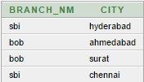

create table customer(cust_nm varchar2(20),city varchar2(20));

insert into customer values('sanjana','ahmedabad');

insert into customer values('sagarika','chennai');

insert into customer values('sagar','surat');

insert into customer values('sonam','hyderabad');

select * from customer;

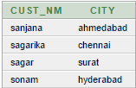

create table borrow(loan_no varchar(20),cust_nm varchar2(20),branch_nm varchar2(20),amount number(20,3));

insert into borrow values('123','sanjana','sbi','1000');

insert into borrow values('132','sagarika','bob','4000');

insert into borrow values('145','sanjana','sbi','5000');

insert into borrow values('12','sagar','sbi','7000');

insert into borrow values('1','sonam','sbi','2500');

select * from borrow;

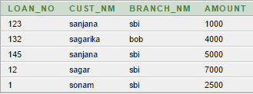

desc deposit;

9

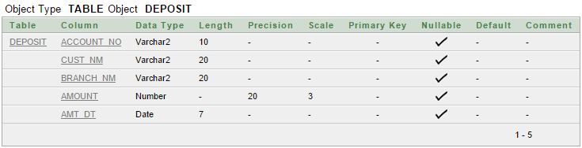

desc customer;

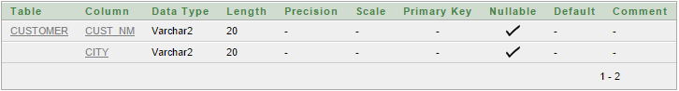

desc branch;

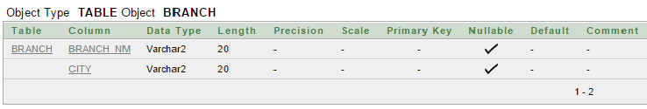

desc borrow;

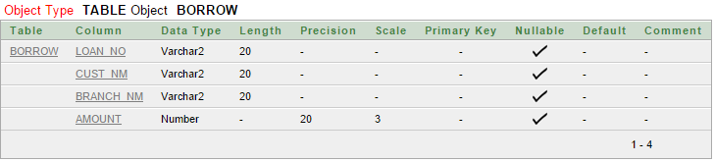

select account_no,amount from deposit;

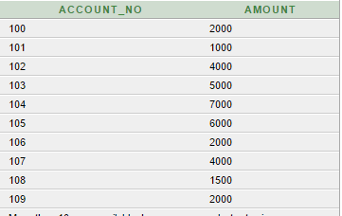

Select cust_nm,amount from deposit where amount>=4000;

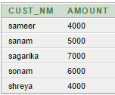

Select cust_nm,amt_dt from deposit where amt_dt between '2-jan-1996' AND '30-dec-1996';

